- Resolve Merge Conflicts
  - Create a merge conflict intentionally (two users editing the same line).
  - Resolve the conflict and push the changes.
  - I created two branches to simulate two users working on the same file.
  - 2. I modified the same line differently in both branches.
  - 3. I committed the changes separately in each branch.
  - 4. I merged the branches and generated a merge conflict.
  - 5. I opened the conflicting file and resolved the conflict by updating the content.
  - 6. I staged the resolved file and committed the changes.
  - 7. I verified the repository status and pushed the resolved changes to GitHub.
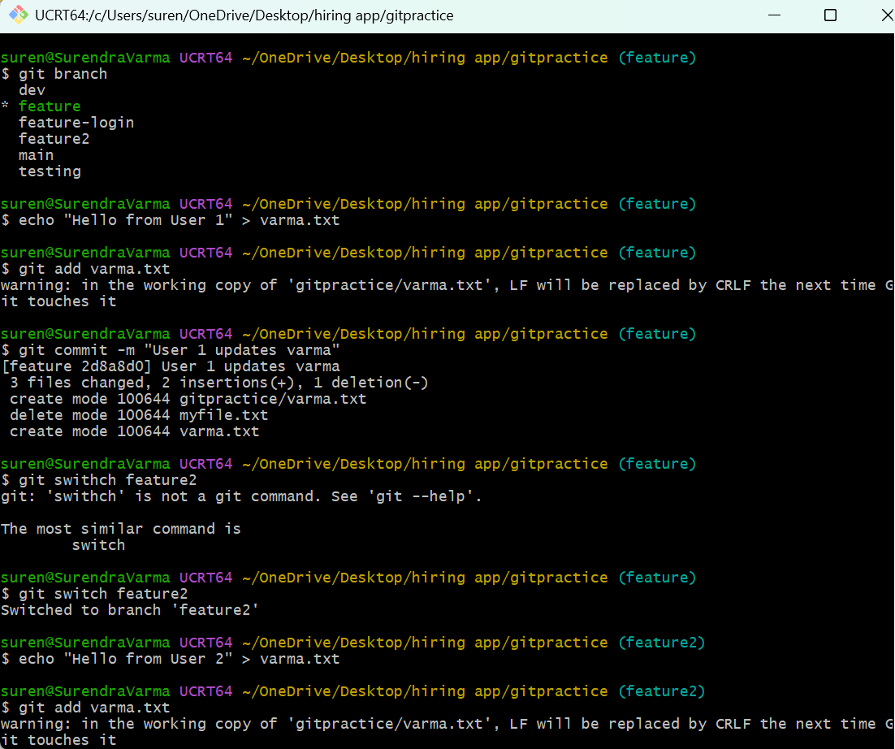
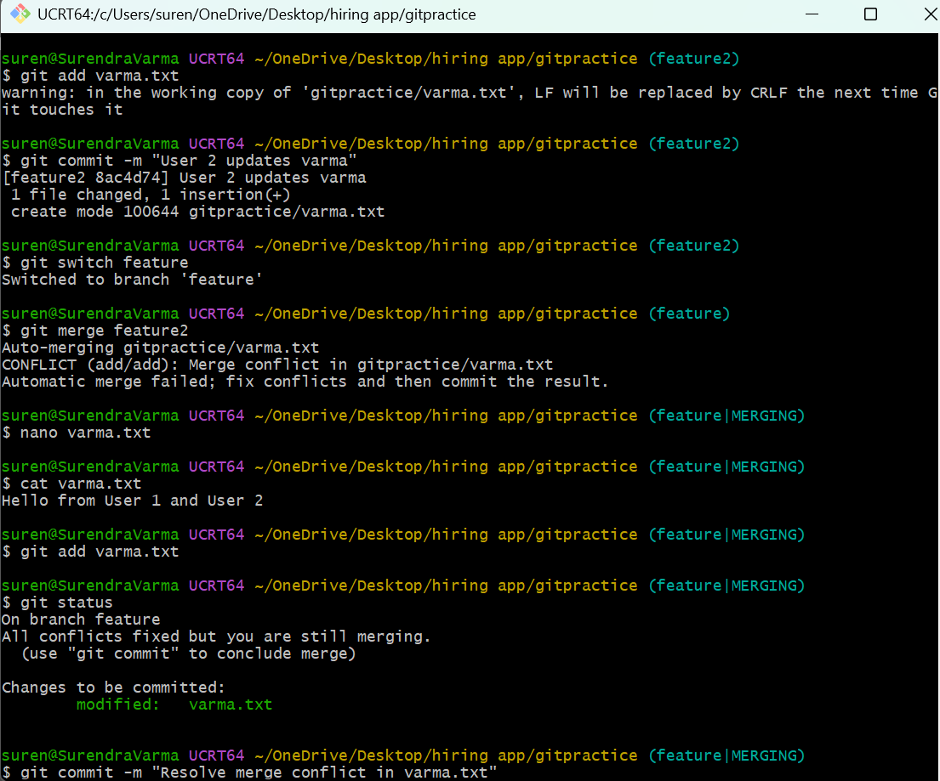
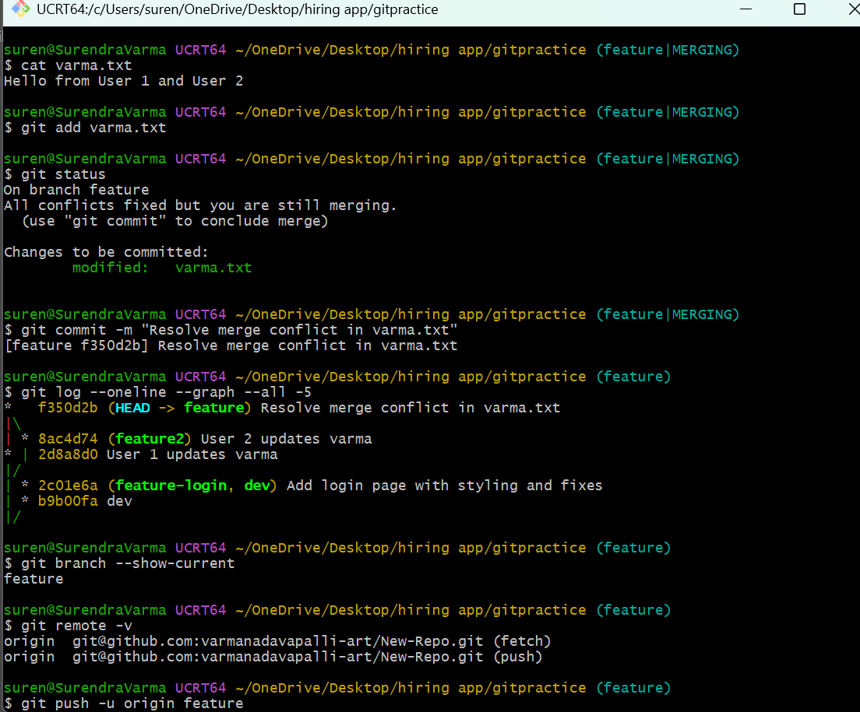
- Recover Deleted Branch
  - Delete a local branch and then recover it using the reflog.
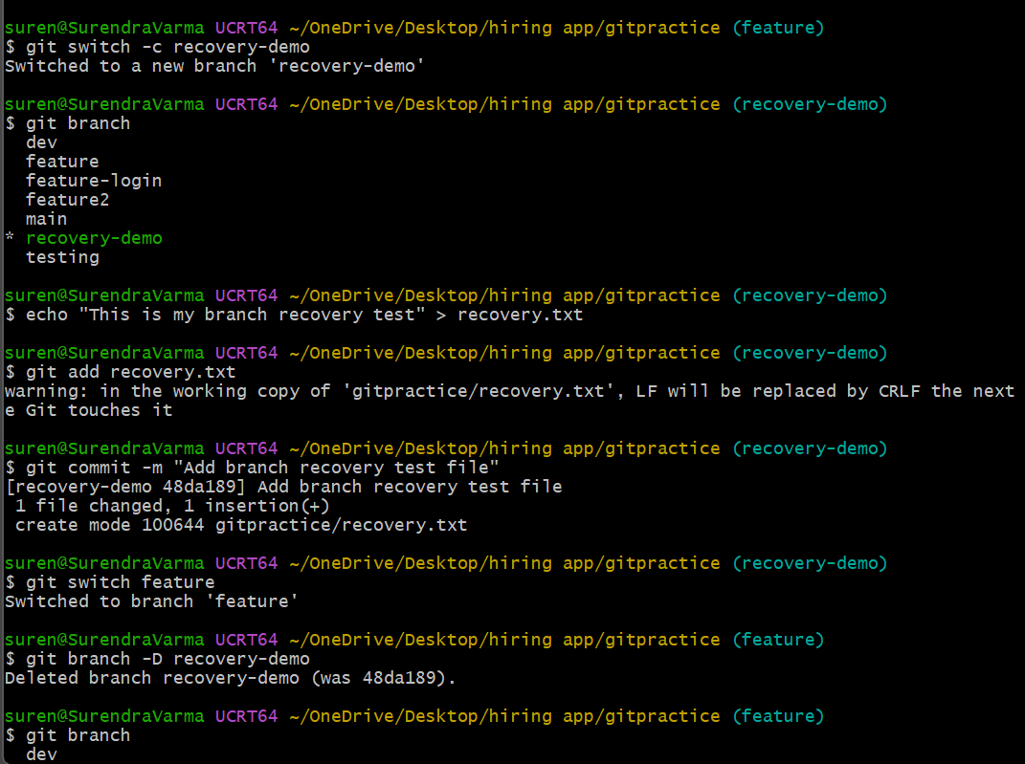
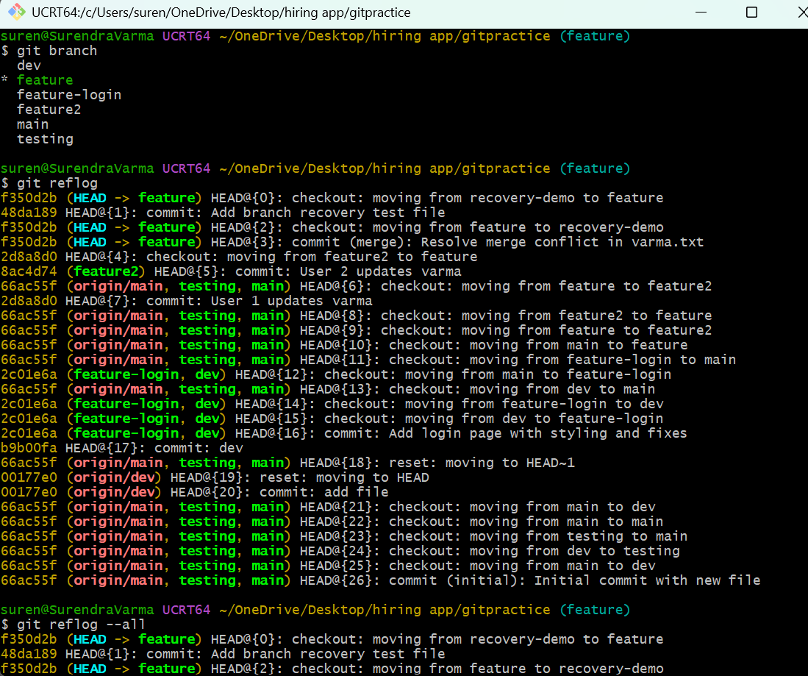
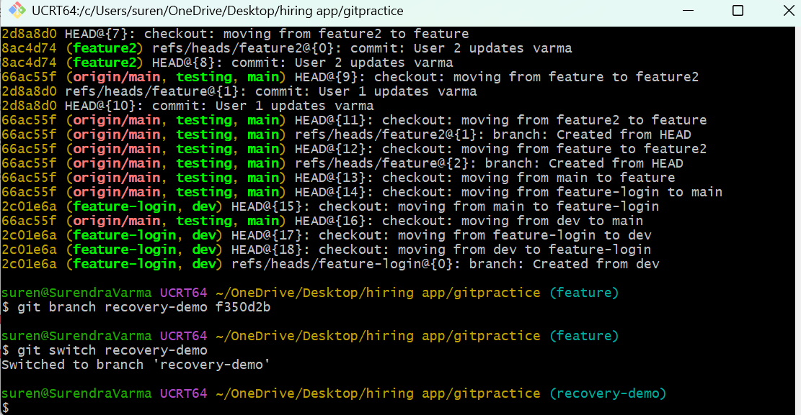
1. I created a local branch and committed a test file.
2. I switched to another branch.
3. I deleted the local branch.
4. I used Git reflog to identify the commit associated with the deleted
branch.
5. I recreated the deleted branch using the recovered commit hash.
6. I verified that the branch was successfully recovered.
7. I checked the branch history to confirm that the commit was available.
- Undo Wrong Push
  - Push a wrong commit to GitHub, then undo it without losing history.
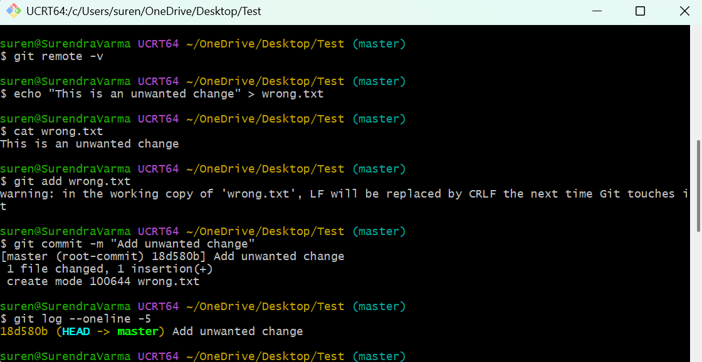
1. I created an unwanted change in my local Git repository.
2. I staged and committed the change.
3. I pushed the unwanted commit to GitHub.
4. I identified the incorrect commit using Git log.
5. I used Git revert to undo the changes without removing the original commit
from history.
6. I verified the revert commit and confirmed that the unwanted change was
removed from the current version.
7. I pushed the revert commit to GitHub and verified the updated commit
history.

- Amend a Commit
  - Make a commit, then add a missing file to it using git commit --amend.
Steps:
1. I created a file and committed it to the local Git repository.
2. I created a second file that was missing from the previous commit.
3. I staged the missing file.
4. I used git commit --amend --no-edit to add the missing file to the
previous commit without changing the commit message.
5. I verified the amended commit using Git log and Git show.
6. I confirmed that both files were included in the amended commit.
7. I pushed the changes to GitHub, if required
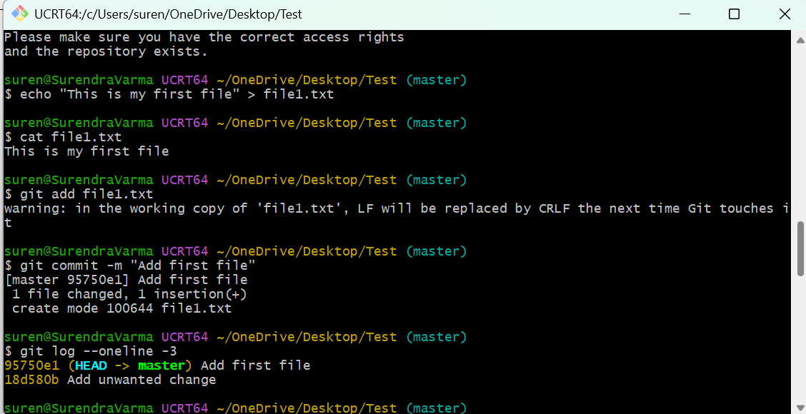
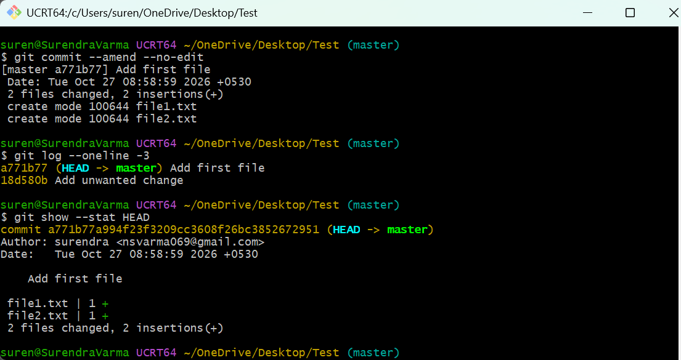

- Cherry-pick a Commit
  - Take a specific commit from one branch and apply it to another branch.
I created a source branch and made a commit containing the required changes.
I identified the specific commit ID using the Git log.
I switched to the target branch where I wanted to apply the changes.
I used the cherry-pick operation to apply the selected commit to the target branch.
I verified the commit using the Git log.
I confirmed that the changes were applied successfully to the target branch without
merging the entire source branch.
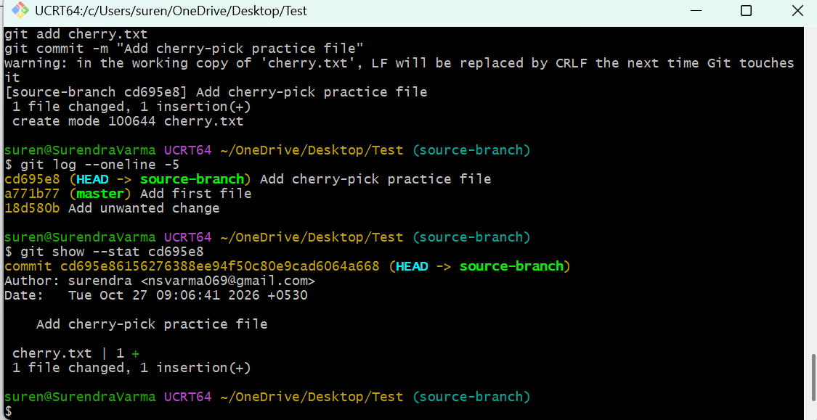

- Interactive Rebase
  - Reorder and squash multiple commits into a single clean commit.

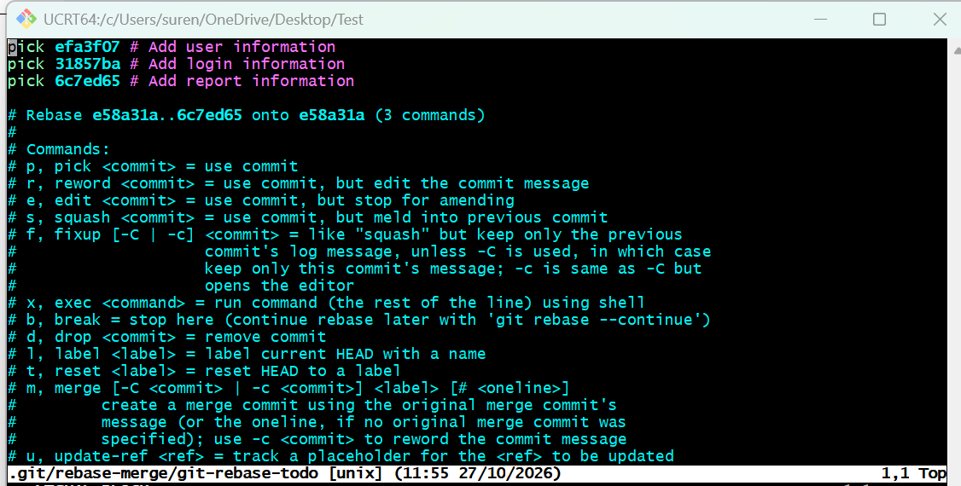
I checked the existing commit history in the Git repository.
I started an interactive rebase to modify the last three commits.
I reordered the commits into the required sequence.
I used the squash option to combine multiple commits into one.
I updated the combined commit message with a meaningful description.
I verified the updated commit history to confirm that the changes were combined
successfully.

- Tagging & Release
  - Create a version tag (v1.0), push it to GitHub, then delete and restore it.
Steps:
Create tag | git tag -a v1.0 -m "Release version 1.0"
Push tag | git push origin v1.0
Delete local tag | git tag -d v1.0
Delete GitHub tag | git push origin --delete v1.0
Restore tag | git tag -a v1.0 <commit-hash> -m "Release version 1.0"
Push restored tag | git push origin v1.0
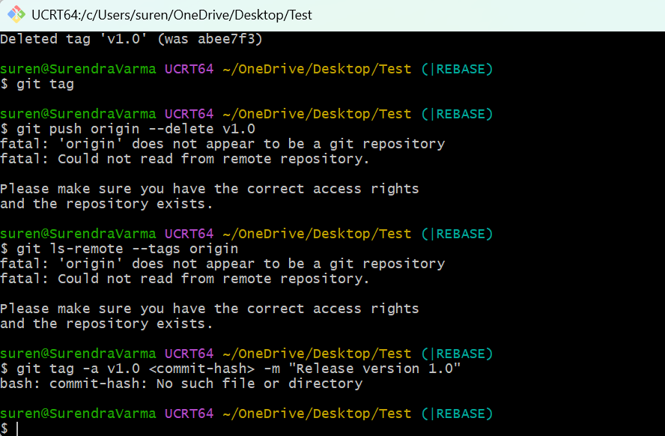

- Clone with Sparse Checkout
  - Clone only a subdirectory of a repo using sparse checkout.
Task
Command
Clone without checkout
git clone --filter=blob:none --no-checkout REPO_URL
Enter repository
cd REPO
Enable sparse checkout
git sparse-checkout init --cone
Select a directory
git sparse-checkout set docs
Verify selected directories
git sparse-checkout list

- Reset vs Revert Challenge
  - Demonstrate the difference between git reset --hard and git revert in a repo.

Feature | git reset --hard HEAD~1 | git revert HEAD
Removes the latest commit from current branch history | Yes | No
Creates a new undo commit | No | Yes
Rewrites branch history | Yes | No
Updates working files | Yes | Yes
Usually safer for shared branches | No | Yes
Easy way to remember:
- Reset: Move the branch pointer backward.
- Revert: Keep the history and add a new commit to undo the changes.

- Detached HEAD Challenge
  - Checkout a specific commit (detached HEAD state) and create a new branch from it.

Command | Purpose
git log --oneline -5 | View recent commits
git checkout <commit-hash> | Check out a specific commit
git status | Verify detached HEAD
git switch -c new-feature | Create a branch from that commit
git branch | Verify the branch
git commit | Save new work on the branch

- Git Hooks Challenge
  - Configure a pre-commit hook to reject commits without a message format (e.g., must start with JIRA-XXX).
- Squash Merge vs Rebase Merge
  - Show the difference between squash merge and rebase merge with evidence.
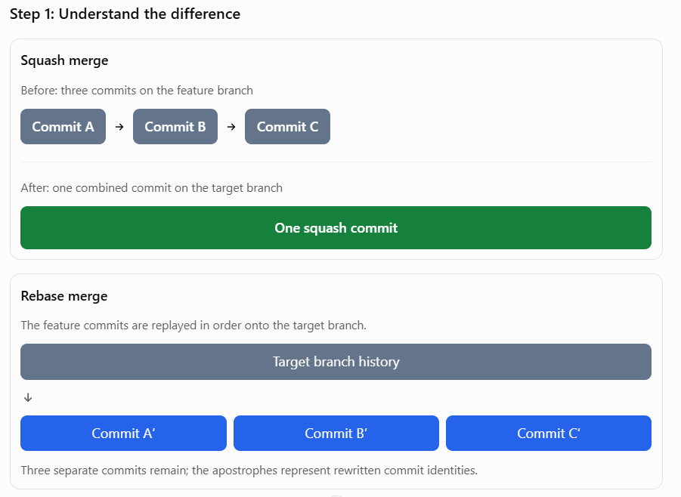

- Fork & Pull Request Workflow
  - Fork a repo, make a change, and submit a pull request to the original repo.
Steps:
# Clone your fork
git clone https://github.com/YOUR-USERNAME/demo-project.git
cd demo-project

# Create a feature branch
git switch -c add-practice-change

# Create a file
echo "My first contribution using a pull request" > contribution.txt

# Stage and commit
git add contribution.txt
git commit -m "Add contribution practice file"

# Push to your fork
git push -u origin add-practice-change

- Recover Lost Commit
  - Commit something, reset hard, and then recover it using git reflog.
Steps
Task
Command
Create a commit
git commit -m "Add important data"
Remove it from current branch history
git reset --hard HEAD~1
Find the lost commit
git reflog
Create recovery branch
git branch recovered-commit <commit-hash>
Switch to recovery branch
git switch recovered-commit
Verify recovered data
git log --oneline and cat demo.txt

